**TASK 16B (i)**

**Technical Report: Sales Performance Analysis**

**Introduction**

**Objective of the Project:** The goal of this analysis is to assess sales performance across various branches of Rexcorp, including salesperson contributions, regional variations, customer segmentation, product performance, and transactional trends. The insights derived will help optimize sales strategies and improve revenue generation.

**Problem Being Addressed:** This report aims to identify key revenue drivers, understand sales trends, and evaluate performance differences among salespersons, products, and customer segments. The findings will support data-driven decision-making for sales and marketing teams.

**Key Datasets and Methodologies:**

* **Datasets:** The analysis utilized a single dataset that covered sales data, customer details, product performance, and transaction distribution.
* **Methodologies:** Microsoft Excel tools such as pivot tables, advanced formulas, and data visualization techniques were used to extract insights.

**Story of Data**

**Data Source and Collection:** The data set originates from internal sales records generated by the company, covering revenue generated over multiple periods. It includes structured information about transactions, sales representatives, customer segmentation, and regional performance.

**Data Structure:**

Each row represents each transaction history, and everything attached to said transaction. Each column represents a variable relating to each transaction. These variables include the order ID, order date, name, ID and address of each customer, Salesperson, name and category of purchased product and the total revenue generated by the company for each transaction.

**Important Features and Their Significance:**

* **Revenue:** Key metric to evaluate financial performance.
* **Salesperson:** Helped identify top performers and areas requiring improvement.
* **Regional Sales Distribution:** Enabled targeted sales strategies for different markets.
* **Customer Segmentation:** Identified high-value customers for personalized engagement.
* **Transaction Patterns:** Assisted in understanding consumer spending behavior.

**Data Limitations:**

i. Some datasets had missing values, and external influencing factors (e.g., market trends, competitive activities) were not included.

**Data Splitting and Preprocessing**

**Data Cleaning:**

* Duplicate entries were removed to ensure data integrity.
* Data formats were standardized for consistency.

**Data Splitting:**

* Sales revenue, unit price, quantity and shipping fees served as the dependent variables.
* Factors like salesperson, region, category, product type and payment type were treated as independent variables.

**Industry Context:** The data belongs to the retail industry.

**Stakeholders:** The chief executives.

**Pre-Analysis**

**Initial Observations:**

* Sales performance varies significantly across regions with the north being the best performing region and generating about $141,360.64 in revenue.
* Top salespeople contributed a major share of total revenue with Nancy generating about $104,242.34 in revenue.
* Product categories show diverse revenue-generating capabilities.

**Potential Correlations:**

* Certain regions consistently outperform others.

**In-Analysis**

**Key Findings:**

* **Best Salesperson:** The top performer generated $104,242.34 in revenue.
* **Top Customer Contribution:** The highest-spending customer accounted for $67,180.50 in revenue.
* **Peak Sales Month:** January had the highest revenue, totaling $32,907.84.
* **Best Performing Product:** Beverages contributed the highest revenue ($110,577.11).
* **Top Region:** The Northern region led sales with $141,660.34 in revenue.

**Recommendations:**

1. Nancy performed the best and I recommend that she be rewarded/promoted to a more senior level in the least performing region (west).

2. Jan performed the least for the year, and I do recommend to the stakeholders that he be retrenched or sent over for some trainings on sales and customer retentions.

3. Company D should be offered some incentives like discounts as a reward for their patronage and to further strengthen business bonds.

4. The measures that were implemented in December that made it the best month should be replicated in February to improve turnout.

5. Some staff should be transferred from the northern region to the western one to boost sales while current western staff should be sent for trainings on customer service and retention.

6. Items within the 0-$1000 price range should be constantly monitored to ensure continuous availability.

7. Bevarges were the most purcahased category of goods and so the stock and inventory team should strictly monitor these products to ensure they do not run out.

**Analysis Techniques Used in Excel:**

* **Pivot Tables:** Used to segment and analyze trends.
* **Formulas:** Employed to compute revenue aggregates and performance metrics.

**Post-Analysis and Insights**

**Confirmed Insights:**

* Certain salespersons and regions consistently outperform others.

**Comparison with Initial Expectations:** The findings validate the assumption that revenue concentration is unevenly distributed among salespersons, customers, and product categories.

**Data Visualizations & Charts**

**Key Visualizations:**

This bar chart shows Nany Freehafer as the best performing sales for the year and Jan Kotas as the worst performing salesperson.

This line chart shows June as the month with the highest generated revenue and February as the least.

The doughnut chart above shows the north as the best performing region and the west as the least performing region.

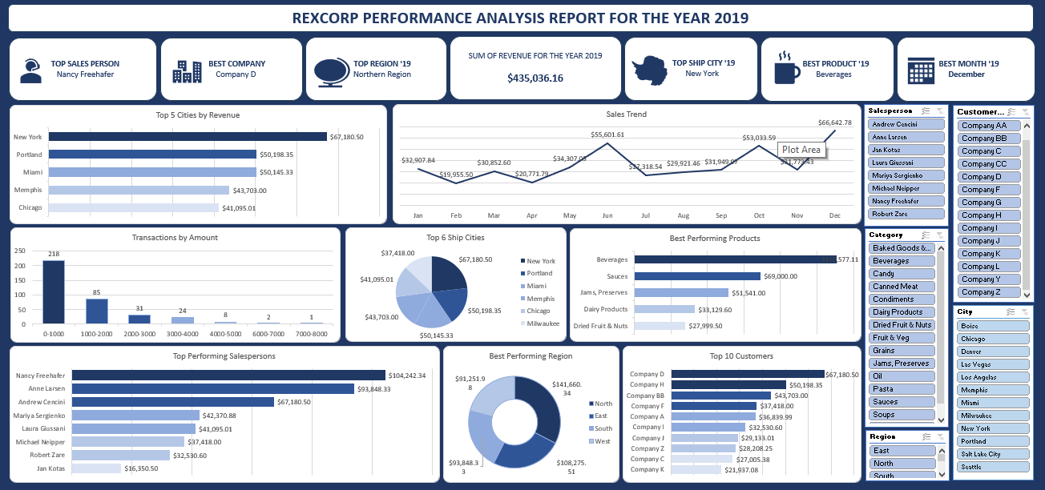

The dashboard above gives a major summary of the entire analysis done on the dataset.

**Recommendations and Observations**

**Actionable Insights:**

* Allocate more resources to high-performing salespersons and regions.
* Focus marketing efforts on top 5 customers to increase repeat purchases.
* Introduce seasonal promotions to capitalize on peak sales months.
* Optimize inventory management for the best-performing products like beverages.

**Unexpected Outcomes:** Despite overall positive trends, certain expected high-performing products underperformed, requiring further investigation.

**Conclusion**

**Key Learnings:**

* Revenue is concentrated among top salespersons and customers.
* Regional sales trends impact overall performance.

**Limitations:**

* Lack of external market factors in the dataset.
* Potential biases in transaction recording.

**Future Research:**

* Extend the analysis to include cost and profit margins for a more comprehensive financial assessment.
* Investigate additional factors influencing customer purchasing behavior.

**References:**

* Internal company sales data.